Digital Signal Processing Lab Assignment 1

**Name:** Ahmed Wael Mohamed

**ID:** 6071

**Group:** 3

**Question 1:**

**Code:**

mean1 = mean(A2Q1);

variance1 = var(A2Q1);

power1 = 0;

disp(mean1);

disp(variance1);

disp(power1);

**Result:**

0.3196

0.1497

0

**Question 2:**

**Code:**

x1 = 4*ones(1, 200);

f2 = 0.25;

t2 = linspace(0, 1, 100);

phase = 90;

phase_in_rad = deg2rad(phase);

x2 = sin((2*pi*f2*t2)+phase_in_rad)+3;

x3 = 3*ones(1, 200);

x = [x1 x2 x3];

t = linspace(-2, 3, 500);

plot(t, x);

ylim([0 6]);

**Result:**

**Question 3:**

**Code:**

y1 = A2Q3_1(1:1000);

y2 = A2Q3_2(1001:2000);

y3 = A2Q3_1(2001:3000);

y4 = A2Q3_2(3001:4000);

y = [y1 y2 y3 y4];

t_tot = linspace(0, 4, 4000);

plot(t_tot, y);

**Result:**

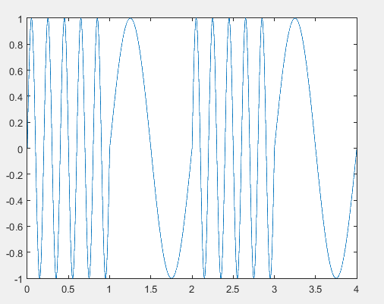

**Question 5:**

**Code:**

hist(A2Q5, 100);

mean1 = mean(A2Q5);

standardDeviation1 = std(A2Q5);

disp(mean1);

disp(standardDeviation1);

**Result:**

**4.9062 and 3.1041 are the mean and standard deviation**

